OOSE Lab Week 6

Contents

1 Create a Communication Diagram 1

2 Convert the Communication Diagram into a sequence diagram 1

3 Write an piece comparing the two diagrams 1

4 Submit 2

Week 6

# Create a Communication Diagram

Create a Communication Diagram using Visual Paradigm.

Choose a domain of your choice. The diagram should have a number of objects.

Export an image of your diagram into a Word (or other) doc.

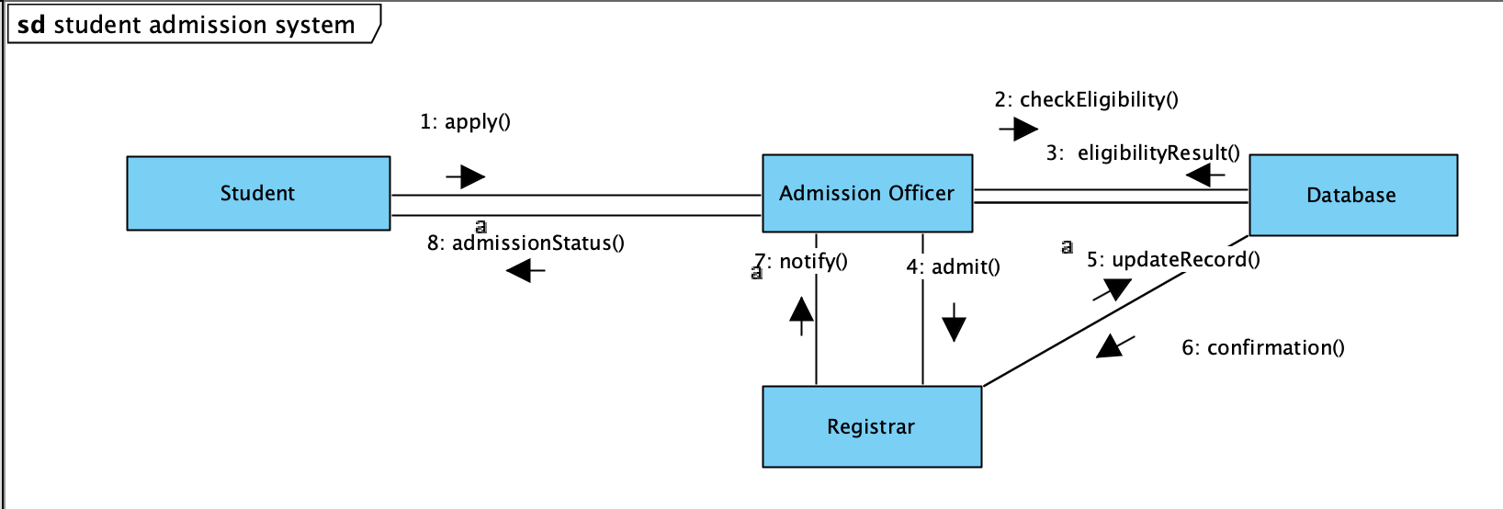

# Convert the Communication Diagram into a sequence diagram

Use the Visual Paradigm automatic converter to convert the Communication Diagram into a Sequence Diagram.

Add an image of the sequence diagram into the Word document.

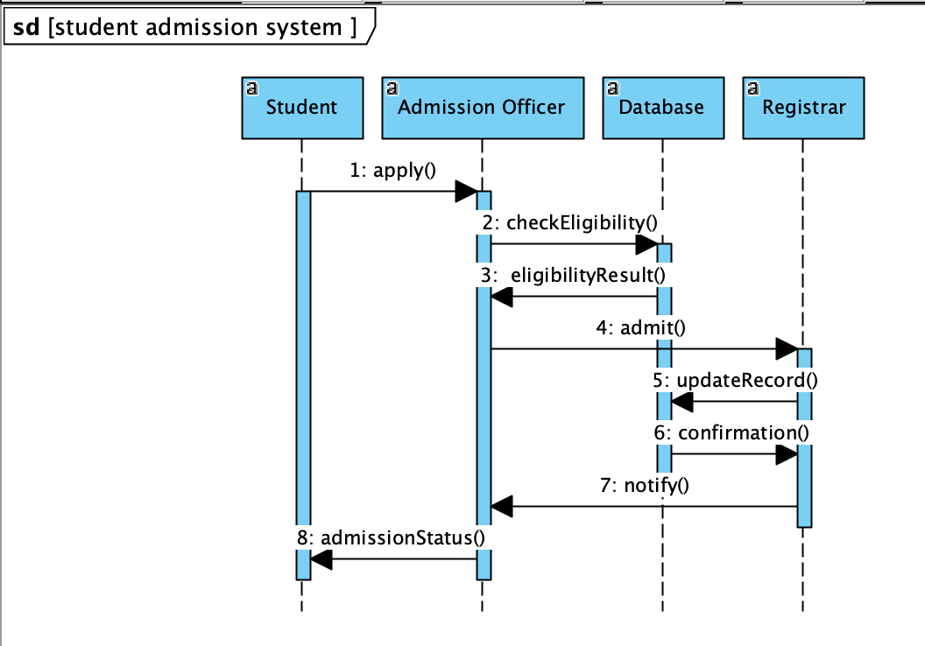

# Write an piece comparing the two diagrams

Write approximately 200 words giving your opinion of relative merits of the two diagrams that you have created.

Sequence diagrams are useful for illustrating the order in which messages are exchanged and the connections between different parts of a system. They provide detailed information that is helpful for better visualizing the overall flow and real-time specifications and for complex scenarios.

On the other hand, communications diagrams offer a higher-level perspective on how components communicate within a system, show relationships in addition to interactions, and more easily visualise all of the effects on a given object. They are also easier to use for brainstorming sessions.

In brief, sequence diagrams play a crucial role in comprehending the sequencing of messages and complex real-time scenarios, whereas communications diagrams offer a broader view of system communication, highlighting relationships and overall interactions.

# Submit

Submit the diagrams and text in one document.